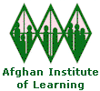
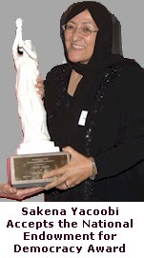
The Afghan Institute of Learning has continued to expand its renowned training, education, and health programs in Afghanistan and Pakistan during 2005. Health and education services were established in new places in Afghanistan, especially rural villages and urban poor communities.

Accomplishments of the Afghan Institute of Learning 2005

National Endowment for Democracy Award

In July of 2005, the Afghan Institute of Learning and its Executive Director, Sakena Yacoobi, were honored with the 2005 Democracy Award of the National Endowment for Democracy. The award recognized their efforts to educate average citizens and local leaders about the basic values and principles of democracy, the rights of women and ethnic minorities, strategies for peace-building and conflict resolution and the importance of broad political participation.

Teacher Training

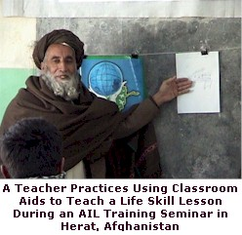
AIL has continued its teacher training program during 2005 and expanded it to the village of Farza in rural Kabul province. To date, AIL has trained 10,000 teachers in interactive, student-centered teaching and demand for more training from teachers, school administrators, and parents remains strong. During the first six months of 2005, AIL offered:
- Three Logic and Linguistics of Arabic subject matter teacher training seminars (12 days each) in Mir Bacha Kot, Kalikhan, and Farza for 113 male teachers
- Seven teacher training technique seminars (24 days each) in Peshawar, Herat, and Farza for 268 teachers, including 129 female teachers
- Teacher training workshops on a range of topics including teaching methods, administration, and life skills lessons for 572 teachers in Kabul, Herat, and Peshawar

One teacher who completed an AIL training commented: “The workshop was very helpful. Nowadays, these topics are very important because these topics are the need of Afghanistan. There was 25 years of war in Afghanistan. We have to learn these topics and have to rebuild our country and keep our children far from the war because they are the future of Afghanistan.”

Other Training

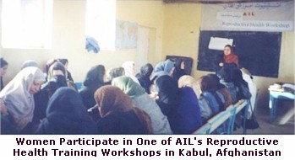
The success of AIL’s teacher training project is due to the quality of the training prepared by AIL’s Master Teacher Trainers. They use interactive, student-centered teaching techniques and allow participants to practice lessons through hands on exercises that facilitate the application of lessons learned in training to the workplace and other settings. As a result, AIL Master Teacher Trainers have been asked to prepare and offer trainings on a wide variety of subjects to meet diverse needs. For example, AIL trains illiterate rural women who need to improve their understanding of reproductive health so that they can deliver healthy babies safely. AIL also trains government officials in various departments, especially the Ministry of Women’s Affairs to improve their management and leadership. During the first six months of 2005, AIL offered trainings including:
- Leadership workshops for 150 participants from the Ministry of Women’s Affairs in Herat, the Deputy of Literacy in Kabul, and the villages of Shakardara in rural Kabul province. Traditionally, leadership workshops are offered to women but these workshops included 27 male participants as a method of increasing understanding of gender issues among Afghan men.
- Reproductive health workshops for 60 women in Herat
- Information Technology training for 29 students, including 17 women, in Herat
- An international training conference in leadership for 23 Ministry of Women’s Affairs staff at the AIL office in Kabul
- The first Management Workshop for 17 women in Kabul. Participants learned how to manage women’s learning centers. This training was developed by AIL managers who have established dozens of Educational Learning Centers in Afghanistan and Pakistan since 1995.

Educational Learning Centers

AIL has continued to expand its Educational Learning Centers program and offer a diverse array of educational opportunities to Afghan women, children, and youth through schools, home schools, advanced classes, pre-schools, Women’s Learning Centers, and grassroots, community-based educational organizations. In total during the first six months of 2005, AIL offered learning opportunities to 9,299 women, children, and youth at 34 center locations in Afghanistan and Pakistan. All of the centers adhere to AIL’s policies and procedures including the use of interactive, student-centered teaching methods. Women and children served included:
- 852 students, including 392 girls, in three AIL-supported schools near Jalalabad in Nangahar Province, Afghanistan
- 1,997 students, including 1,030 girls, in six AIL-supported refugee schools in Pakistan
- 2,813 students in Women’s Learning Centers in Kabul and Herat, Afghanistan and Peshawar, Pakistan. Two new centers, called Etefaq Mosque and Salman Farse, were added in poor areas of Kabul city.
- 2,645 students in AIL-supported grassroots community-based organizations (CBOs) in Kabul and Herat, Afghanistan. One new CBO was added in Herat province called Zainabia School. These CBOs are under the training and supervision of AIL staff as they shift their teaching to include quality, interactive, student-centered lessons.
- 770 students in two home schools and advanced classes in the villages of Mir Bacha Kot, rural Kabul province
- 222 students in pre-schools in Kabul, Herat, and Pakistan

One of the students of Habibi Educational Center, a Center in Kabul province supported by AIL, said: “My name is Ruqia and I am 20 years old. I am studying Arabic and English. I am so thankful for this center and my teachers because they have really helped me a lot. When I came to this center, I did not have too much knowledge. I had studied just up to third grade in school. Then I lost my leg in the war and I was not able to go to school. I couldn’t complete my education because there were no courses near our house but I was so interested in studying. I joined Habibi Center when it opened and I have learned a lot.”

Health Clinics & Health Education

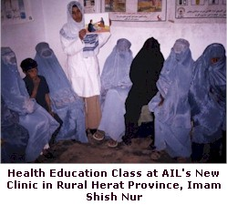
AIL’s health program continues to save hundreds of thousands of lives with urgently needed health care services. AIL’s four clinics specifically focus on providing maternal and child health care because Afghans suffer some of the world’s highest maternal and child mortality rates. Services offered include pre- and post-natal care, medical exams, baby delivery, vaccination, family planning, and nutrition care. During the first six months of 2005, AIL’s Health Program:
- Offered health services to 38,505 patients through four stationary clinics and mobile clinics in Kabul and Herat, Afghanistan and Peshawar, Pakistan.
- Added a new clinic in rural Herat, Afghanistan called Imam Shish Nur. This clinic is the only health facility in the area but its funding had run out and it was in danger of closing. With AIL’s assistance, this medical facility is able to continue serving over 2,000 patients each month
- Provided health education to 40,681 women and children on topics like hygiene, disease prevention, nutrition, and reproductive health. Health education is an important strategy for preventing disease and keeping women and children healthy.

One student of AIL’s Lolenge Educational Center in Parwan Province said this about the health education he has received from AIL, “My name is Mujeeb. It is very good that students are taught about the harms of narcotic drugs in this center. This is very effective for people, especially in today’s conditions and in rural areas, where most people are involved in cultivating and using narcotics. Now that we have information about the harms of narcotic drugs, we will never allow anybody in our family or village to cultivate or use them. We thank AIL for its services.”

Gawhar Shad University

In 2002, AIL opened Gawhar Shad University in Pakistan and developed three curriculum tracks; the College of Nursing/Health Education, the College of Math and Computer Science, and the College of Education. The university has a computer lab and a small library. Through Gawhar Shad University, AIL is preparing Afghan professionals with the skills and education needed to develop solutions to the many problems facing Afghanistan. During the first half of 2005, Gawhar Shad University:
- Served 150 students in the College of Math and Computer Science, including 82 women
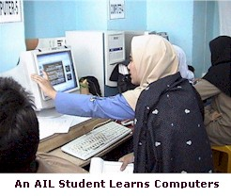
- Graduated its first class of students from the College of Math and Computer Science in August 2005 after six semesters of study
- Graduated 8 students from the Nurse/Health Educator Training College. To date, 59 women have graduated from this program and are providing quality health care services to tens of thousands of Afghan women each year.
- Fifteen students are studying to be Master Teacher Trainers through AIL’s College of Education
- Four women completed their studies and became Master Teacher Trainers during 2005

******************************************************************************

In its tenth year of operation, the Afghan Institute of Learning continues to demonstrate its capacity to develop innovative responses to the changing needs of Afghan women and children in spite of ongoing uncertainty in the region. AIL staff remain as committed as ever to bringing healthcare and education to Afghan women, children, and youth in response to their urgent needs. AIL is looking forward to continuing and expanding its work during the remainder of 2005 and in the coming years. They will reach even more women and children in need, train more Afghan professionals to lead the country’s reconstruction efforts, and strengthen Afghan civil society by training and supporting more organizations.

